Form for video display terminal workers
Work activities carried out mainly in studio / office
Personal Data sheet

First name
Last name
Nationality and citizenship
Fiscal code
Gender
Title
Date of birth
Email
Phone number
Local address
Start date
End date
Qualification
Perugia University Department

Describe your activity:
……………………………………………………………………………………………………………………………………………………………………………………………………………………………………………………………………………………………………………………………………………………………………………………………………………………………………………………………………………………………………………………………………………………………………………………………………………………………………………………………………………………………………………………………………………………………………………………………………
……………………………………………………………………………………………………………………………………………………………………………………………………………………………………………………………………………………………………………………
……………………………………………………………………………………………………………………………………………………………………………………………………………………………………………………………………………………………………………………

Do you use vdt? yes no

If the answer is “yes”, indicate if the VDT workstation complies with the devices of Annex XXXIV of Legislative Decree 81/08

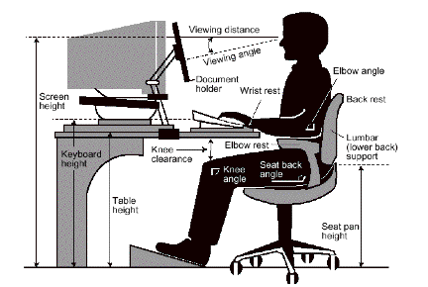
Screen | yes no | If no, explain why not:
Chair | yes no | If no, explain why not:
Keyboard | yes no | If no, explain why not:
Table | yes no | If no, explain why not:

How long do you work on your computer every day?
between 60 and 240 minutes per day
more than 240 minutes per day
How many days a week? Are you over 50 years old? yes no
OTHER RISKY ASSETS: e.g. microclimate / macroclimate, protracted fixed posture, incongruous posture, repetitive movements of upper limbs, dust
……………………………………………………………………………………………………………………………………………………………………………………………………………………………………………………………………………………………………………………………………………………………………………………………………………………………………………………………………………………………………………………………………………………………………………………………………………………………………………………………………………………………………………………………………………………………………………………………………

Date……………………… Worker signature…………………………………………

Employer/Director signature…………………………………

